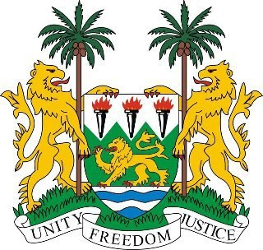
SIERRA LEONE
20th Session of the Universal Periodic Review

GAMBIA

Statement by Ambassador Yvette Stevens

28 October 2014

Mr President,

Sierra Leone welcomes the delegation of Gambia and thanks them for the presentation of the comprehensive national report.

My delegation commends Gambia for the remarkable progress it has made in the social and economic spheres and in improving the living standards of its people; for the recent legislation addressing and criminalising sexual and gender-based violence against women and for reinforcing the National Plan of Action against the Sexual Abuse and Exploitation of Children.

My delegation notes Gambia’s efforts to establish a National Human Rights Institution, and to establish protection mechanisms for refugees, and urges Gambia to intensify its efforts to achieve these goals.

Sierra Leone would also like to urge Gambia to promote the freedom of expression, association and peaceful assembly in the country in accordance with international conventions.

Sierra Leone would like to make the following recommendations for consideration by Gambia:

- Consider drawing up legislation to rise the legal age of marriage to 18 years.
- Seek technical assistance to improve the judiciary, in order to more adequately execute its functions and enhance effective and efficient justice delivery.
- Ratify the CAT
- Submit the long outstanding reports to the Human Rights Committee.

Sierra Leone wishes Gambia every success in this UPR process.

Mr President, I thank you.

